Revision- Unit6 Happy birthday
佛山市禅城区环湖小学 赖欣怡
【教学内容分析】
本课教学内容为人教版英语三年级上册unit6 Happy birthday的复习课。本课将结合Dr. Seuss系列的Ten apples up on top绘本巩固本单元重要词汇one-ten及中心句型How many…
【教学目标】
- 通过电子书的展示，能够整体感知绘本内容，从中提取初步信息（谁？在哪里？什么时候？发生什么事？）
- 在老师指导下完成概念图，了解故事发展脉络，并尝试复述
- 能够根据图片、文字结合阅读猜测特定信息（如单词），突破故事理解的难点
- 能够找出本文押韵的单词，如：stop与 drop, down与town, all与fall
【教学重点】
- 复习本单元重点词汇 one, two, three, four, five, six, seven, eight, nine, ten
- 运用本单元重点句型How many… I see…描述绘本图片
【教学过程】
Teaching steps | Teacher’s activities | Student’s activities
Step 1 Warm up and lead in | - Greeting  - Sing the song ten candles from book  - Show an apple on the screen and tell Ss we will enjoy a story about apples. | Greeting  Sing song  Ready to listen to the story
Step 2 Pre-reading | Ask some information about the story from the cover of it.  -What’s the name of the story?  -Can you guess what the story is about? | Guess and answer the question  Title: Ten apples up on top  About: apples, lion
Step 3 While-Reading | - Watch the video of the story for the first time and Think about two questions  ①How many kinds of animals in the story?  ②What are they?  T: There are five animals in the story.  (Lion, dog, tiger, bears and birds)  Then ask Ss to put the animals into right order.（根据出场顺序给动物排序）  - -What is on lion’s head? (Show the P1)  -How many?  Yes, there is one apple up on top.  -How about this one? How many apples? (Show P2)  OK, NOW listen to the story for the second time then fill in the blank  (设计意图：将图片中有关数字的单词挖空，要求学生看图+听补充上去，此处可考察学生对于单词的记忆)  - Oh, Look! How many apples are there on lion’s head?  -Yes, there are ten on top.  Goodness! Someone is running after them three. Who are they?  Let’s keep on reading.  - Bears and birds are running after them three. They want to make the apples fall. But the lion, the dog and the tiger are very smart. They use _______ to help them. What is it?  - What the end of the story? Do the apples fall?  (设计意图：本部分教师为学生梳理故事的脉络，从开始—高潮—结局) | Watch the video and mark down the animals together  Skim the story the find out the order  -Apple.  -One apple.  -Two apples.  Listen and fill in the blank  Read and find out the answer  （学生安静的阅读，寻找答案）  They use the umbrella to help them.  学生安静阅读，寻找答案  No, because they crash on the apple truck. And ten apples on them all!
Step 4 Post-reading | - Show the rhyme words from the story and encourage Ss to read it by themselves  four- more  top-hop-stop-drop-mop  one-fun  eight-skate  drink-think  all-fall-hall  - Read it loud  老师与学生分部分朗读故事，将比较简单以及rhyme words的部分交给学生读  - Help Ss finish concept map  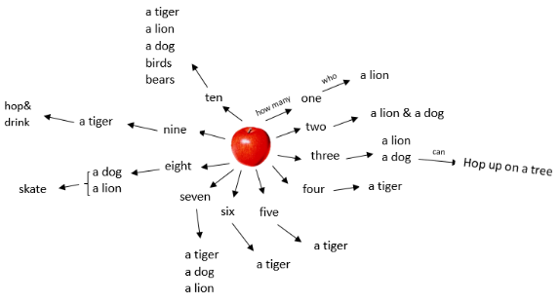  - Ask Ss to retell the story according to the concept map part by part and group by group | 利用小组互助的方式，尝试根据押韵的规律将新词读出来  Read the story together  Finish the concept map of story with group mates together  Retell the story
Step 5 Discussion | Stimulate Ss to discuss who’s your favourite character in the story? Why? | Discuss with group mates
Step 6 Homework | - Read the story to your parents  - Finish the reading response
【板书设计】
Ten Apples up on Top
